**Object Process Methodology Palette for yEd – v1.0**

Contents

2 About the palette 1

3 Installation instructions 1

4 Recommended yEd global preferences 3

5 Quick start 101 pointers 4

6 License 6

# About the palette

The palette described in this manual contains OPM (Object Process Methodology) elements and is intended to be used with yEd software. The library was created as part of the EM.411 MIT 2016 course and it does not cover the whole extend of the OPM modeling language, but the components and relationships we studied during the mentioned course. Future versions of the palette may contain more standard OPM elements.

# Installation instructions

1. Open yEd and right-click in the palette section
2. In the context menu that appears, click on "Manage Palette..."

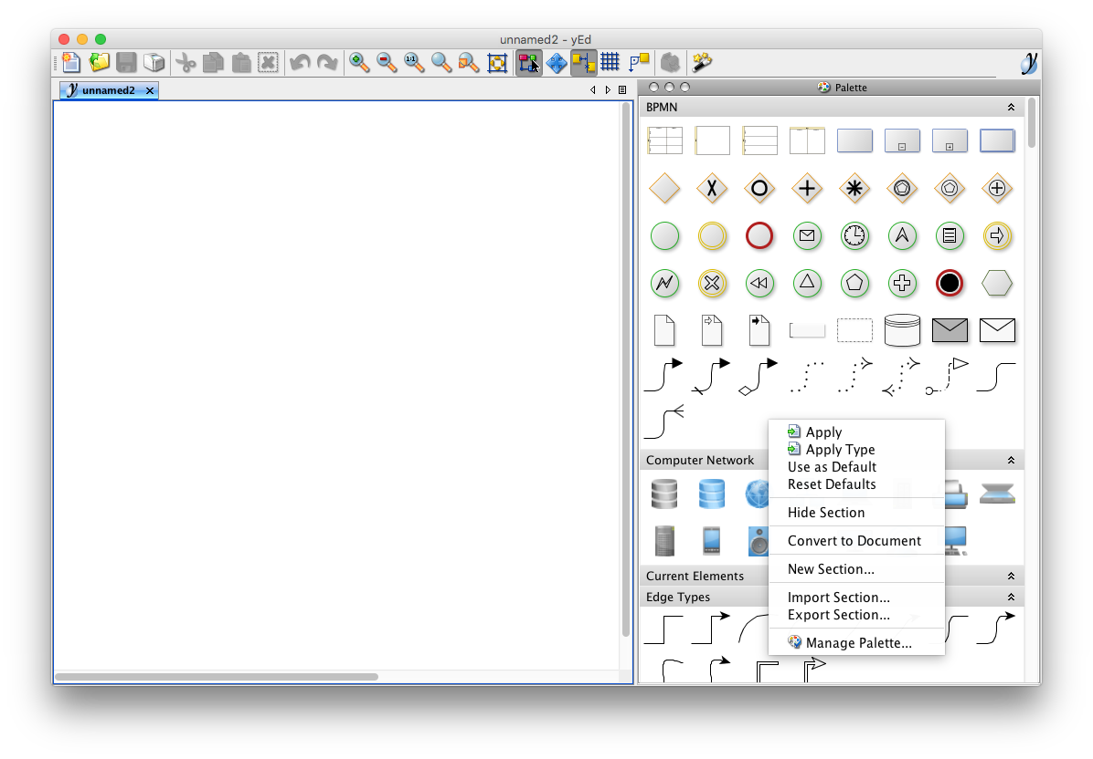

1. In the modal window, click on "Import section..." and import the file OPM_palette.graphml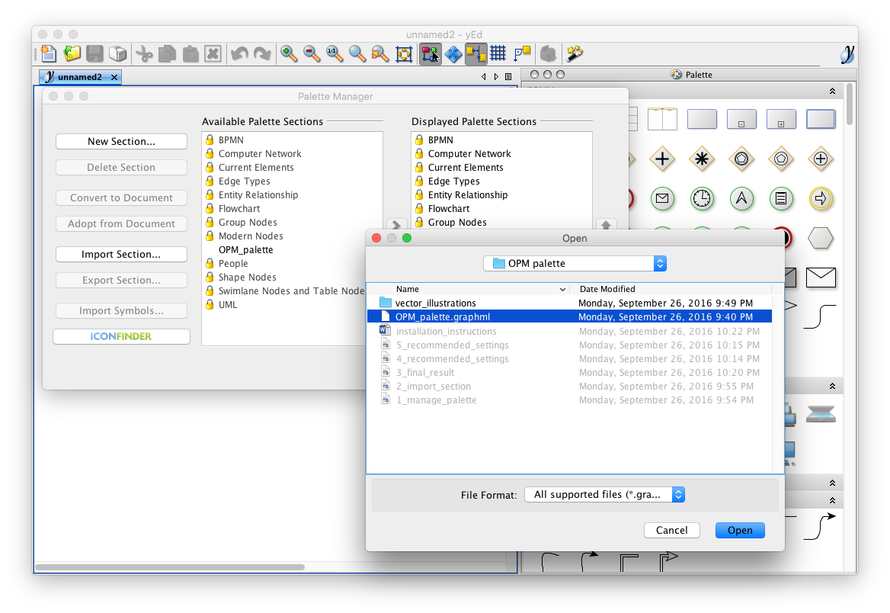
2. You are all set and ready to go!

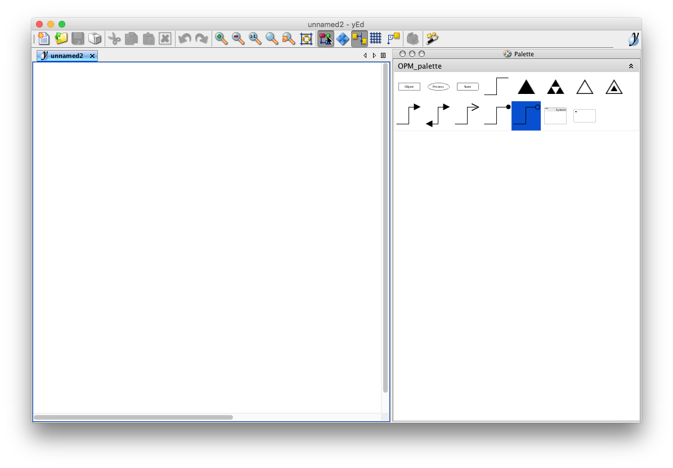

# Recommended yEd global preferences

We find the following set of display and editor preferences handy (File > Preferences). Few options are modified compared to the standard yEd settings. You may want to set these same preferences, or customize them to your needs.

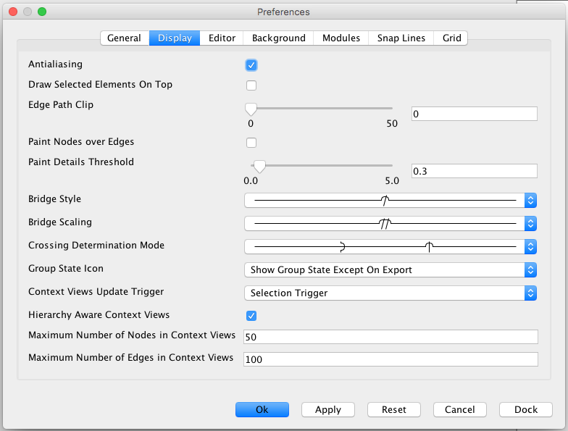

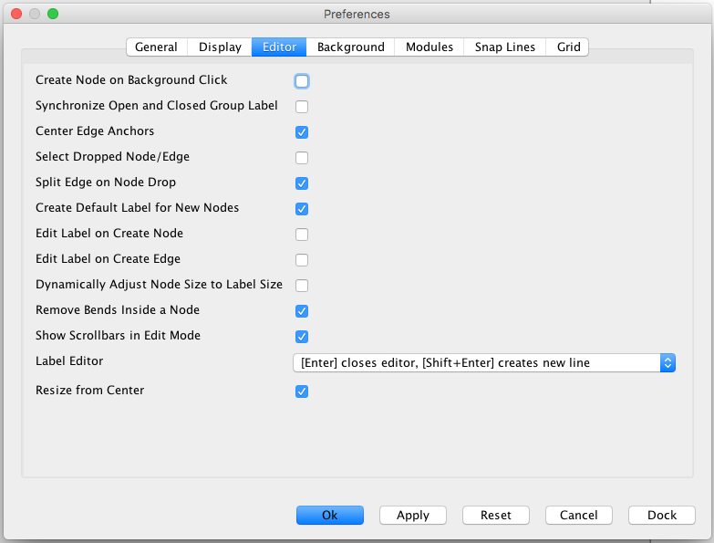

# Quick start 101 pointers

1. Drag the objects from OPM Palettes to the YED document.
2. Select the desired connectivity symbol (e.g. single head arrow) between “Objects” or “Process”.



1. Connect the two “Object” by placing cursor on first “Object” and drag towards the center of second “Object” and release the mouse. The arrow will automatically snap into place.



1. To format the arrows, select the arrow and click the “Properties Views” at the right side of the program (or found under “Windows” on Toolbar) or use “Command” + “I” for Mac Users. E.g. to label the arrows, type into the box beside “Text” in “Properties View”



Or: Use “Command” + “I” and type into text box found under the “General” tab



Select the arrow and then select “Free” under “Placement” found in “Properties View” to move the label freely.



**Hint:** back in the ‘Palette Manager’ you may want to remove from the ‘Displayed Palette Sections’ the palettes you are not going to use, to have a cleaner user interface.

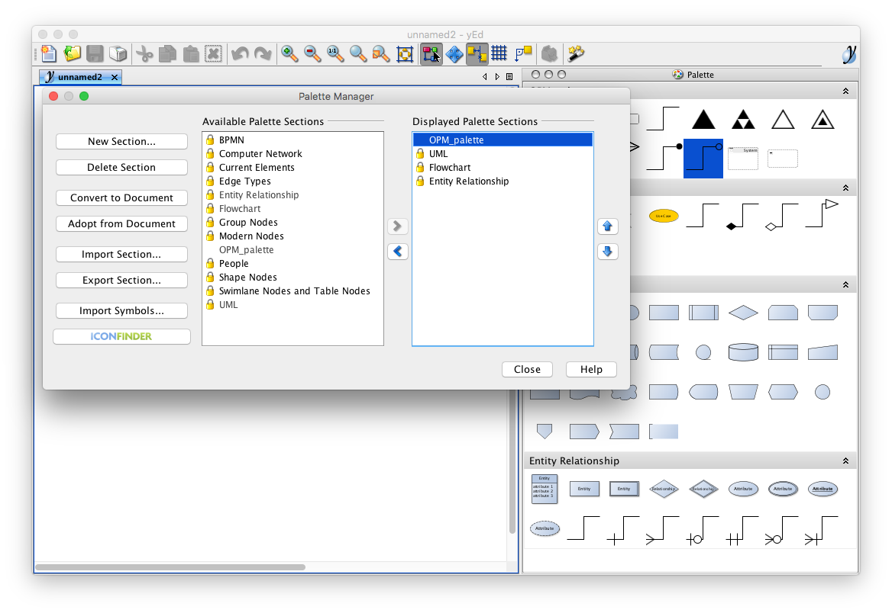

# License

Copyright (c) 2016 Davide Lasi, Aditya Yodha, Rodrigo Diez, and Puay Siang Tan

Permission is hereby granted, free of charge, to any person obtaining a copy of this software and associated documentation files (the "Software"), to deal in the Software without restriction, including without limitation the rights to use, copy, modify, merge, publish, distribute, sublicense, and/or sell copies of the Software, and to permit persons to whom the Software is furnished to do so, subject to the following conditions:

The above copyright notice and this permission notice shall be included in all copies or substantial portions of the Software.

THE SOFTWARE IS PROVIDED "AS IS", WITHOUT WARRANTY OF ANY KIND, EXPRESS OR IMPLIED, INCLUDING BUT NOT LIMITED TO THE WARRANTIES OF MERCHANTABILITY, FITNESS FOR A PARTICULAR PURPOSE AND NONINFRINGEMENT. IN NO EVENT SHALL THE AUTHORS OR COPYRIGHT HOLDERS BE LIABLE FOR ANY CLAIM, DAMAGES OR OTHER LIABILITY, WHETHER IN AN ACTION OF CONTRACT, TORT OR OTHERWISE, ARISING FROM, OUT OF OR IN CONNECTION WITH THE SOFTWARE OR THE USE OR OTHER DEALINGS IN THE SOFTWARE.